a. Finding all the data value in 會員編號 field in 交易記錄檔, which did not appear in 會員記錄檔;

<BR>  
create procedure 會員編號檢查

as

begin

select 會員編號 from [會員資料檔]

where not exists(select \* from [交易記錄檔] where [會員資料檔].會員編號=[交易記錄檔].會員編號)

end

b. Finding all the data value in 產品編號 field in 交易記錄檔, which did not appear in 產品編號檔;

<BR>  
create procedure 產品編號檢查

as

begin

select 產品編號 from [產品資料檔]

where not exists(select \* from [交易記錄檔] where [產品資料檔].產品編號=[交易記錄檔].產品編號)

c. Finding all the illegal refunding record of a customer in交易記錄檔 that the date of the refunding is beyond the allowable days-away for his/her transaction of buying for the same product (the allowable days-away, like 7 days, is a parameter of the stored procedure), and the refunding quantity is larger than that of his/her buying

<BR>  
create procedure 數量不一致退貨

as

begin

MERGE INTO 交易記錄檔$--再匯入一張一樣報表

USING 交易記錄檔

ON 交易記錄檔$.產品編號 = 交易記錄檔.產品編號 --將兩張表的編號MERGE

WHEN MATCHED AND (交易記錄檔$.購買數量 + 交易記錄檔.購買數量 = 0) THEN--當兩張表有資料MERGE時，且庫存量加上進退貨量等於零時，則刪除資料

DELETE;--找出兩張表退貨不一致

select \* from 交易記錄檔$--所有有問題的資料

where 購買數量<0

end

檢查:

1. 對此筆做驗證

select \* from 交易記錄檔$

where 購買數量<0

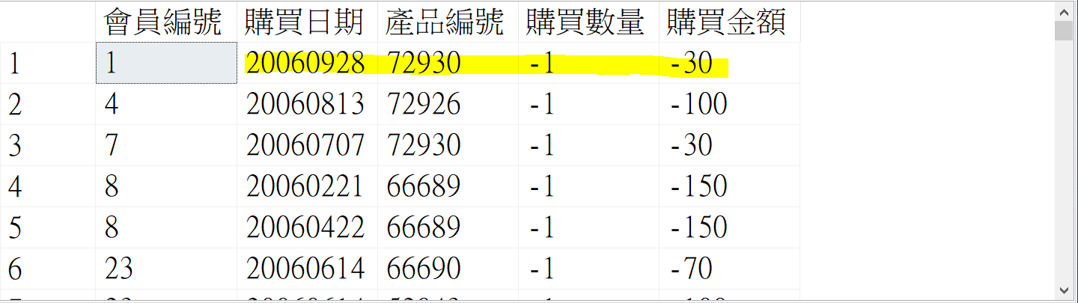

1. 找出就表格資料(有32筆)

select \* from 交易記錄檔

where 會員編號=1 and 購買日期 between 20060921 and 20060928

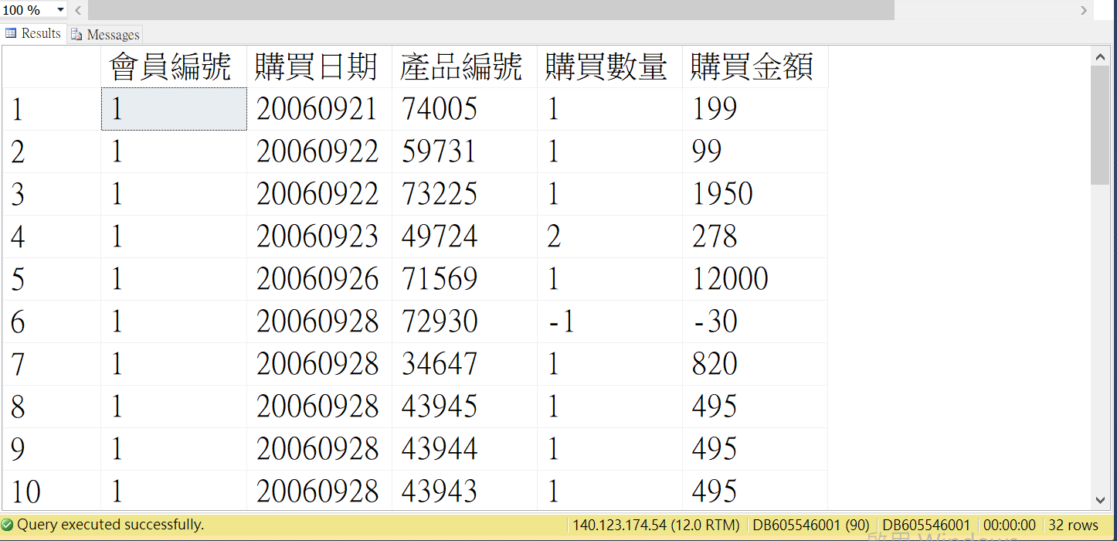

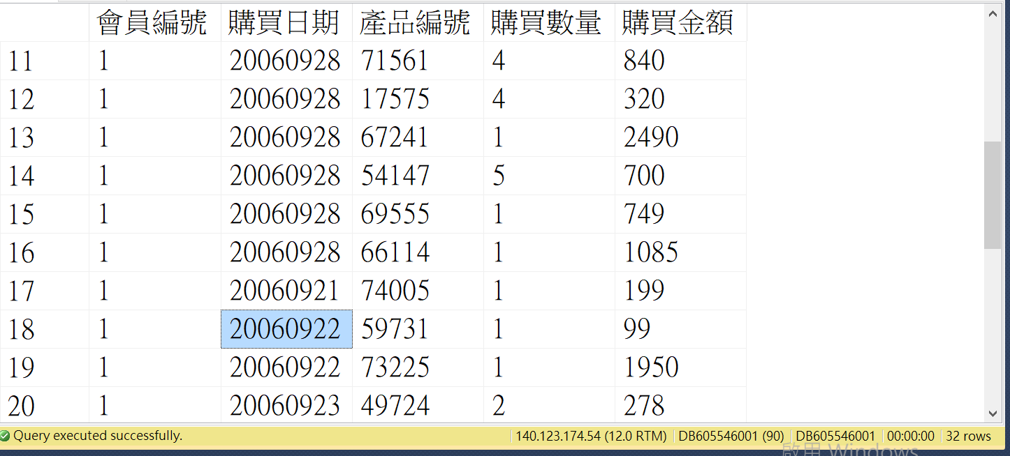

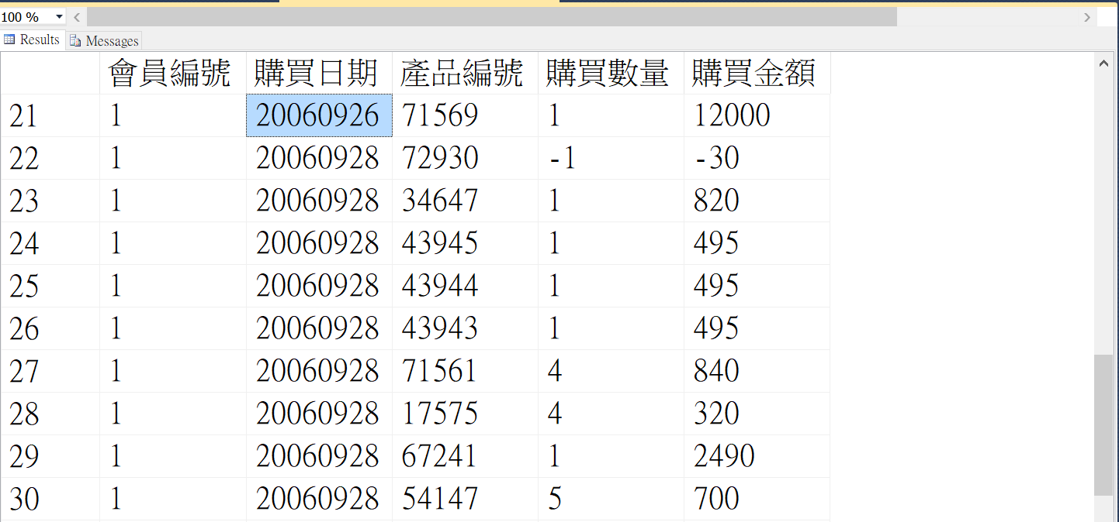



1. 結論:產品編號=”72930”在七天內沒有購買此商品，卻有退貨。

d. Finding the unreasonable data value in 年齡 field in會員記錄檔, which falls outside the legal range of年齡;

<BR>  
create procedure 賣場年齡檢查

as

begin

select \* from 會員資料檔

where 年齡 not between '18'and'100'

e. Finding the pair (品類編號, 品類名稱) in產品編號檔 mismatching the counterpart (i.e., the pair of (品類編號, 品類名稱) in 品類編碼表.

<BR>

create procedure 品類編號與名稱檢查

as

begin

select 品類編號,品類名稱 from [品類編碼表]

where not exists(select \* from [產品資料檔] where [產品資料檔].品類編號=[品類編碼表].品類編號 and [產品資料檔].品類名稱=[品類編碼表].品類名稱)

end